Jenkins Installation Guide
Step 1: Download jenkins.war file
Go to: https://www.jenkins.io/download
And download the war file.
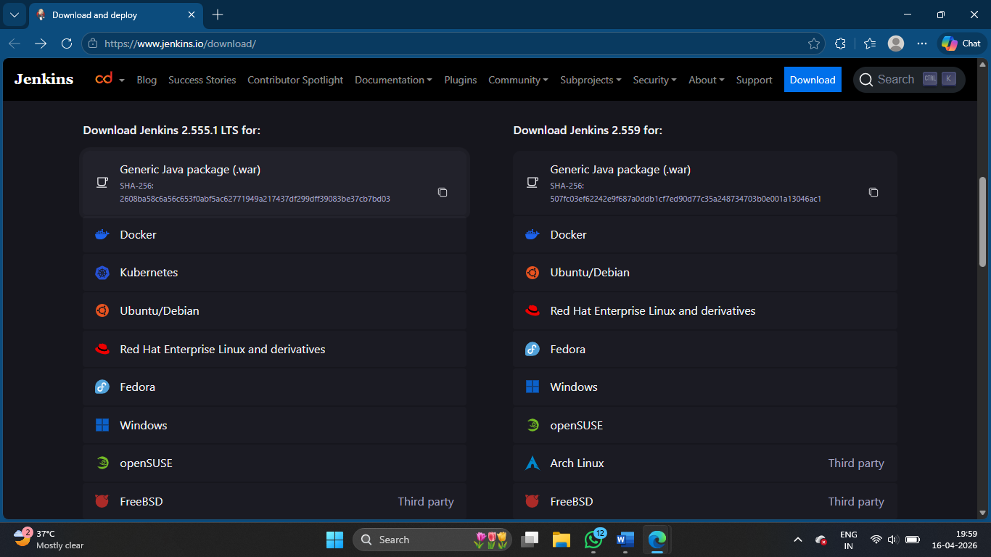

Step 2: Run Jenkins
Open terminal in that folder and run: java -jar jenkins.war

Step 3: Setup Jenkins
Go to: http://localhost:8080
Setup the Jenkins by installing suggested plugins, create login credentials, setup the Java, GitHub and Maven as usual.

Step 4: Create Project
Create a new project and configure like how we did in normal Jenkins, and click Build.

Now you can see the browser GUI

